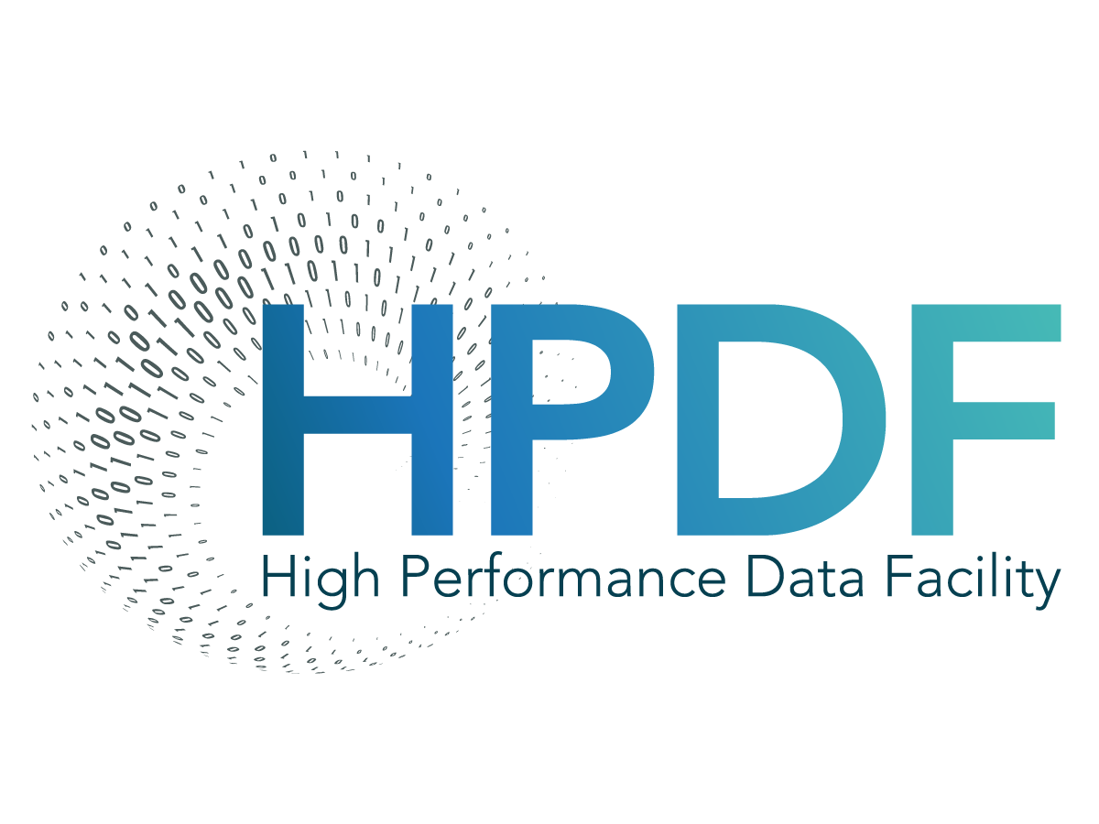

HPDF Technical Document

HPDF-2025
April 24, 2025

This material is based upon work supported by the U.S, Department of Energy, Office of Science, Office of Advanced Scientific Computing Research under contract
DE-AC05-06OR23177

This report was prepared as an account of work sponsored by an agency of the United States Government. Neither the United States Government nor any agency thereof, nor any of their employees, makes any warranty, express or implied, or assumes any legal liability or responsibility for the accuracy, completeness, or usefulness of any information, apparatus, product, or process disclosed, or represents that its use would not infringe privately owned rights. Reference herein to any specific commercial product, process, or service by trade name, trademark, manufacturer, or otherwise, does not necessarily constitute or imply its endorsement, recommendation, or favoring by the United States Government or any agency thereof. The views and opinions of authors expressed herein do not necessarily state or reflect those of the United States Government or any agency thereof.

Revision History
Rev. # | Effective Date | Description
0A DRAFT | April 24, 2025 | Initial Draft release.
0B DRAFT | Nov 10, 2025 | Added addressing plan based on ARIN allocations

1 Overview 5

1 Overview

